Instructions: Instructions: Read each question and examine the included diagrams carefully. Select the best answer from the six available options.
Refer to the notes here to help answer the questions: Vector Kinematics and Dynamics
Offline Paper HW: U1HW8 - W11 - Vector Kinematics and Dynamics 1_questions.pdf
1. What is the primary focus of dynamics?
• The study of why objects move, examining how forces cause objects to accelerate, slow down, or turn.
• The mathematical description of motion without considering the underlying forces.
• The measurement of an object's total mass without spatial coordinates.
• The study of stationary fluids and hydrostatic pressure.
• The calculation of electromagnetic waves in a vacuum.
• The study of chemical reactions in dissolving solutes.
Answer:
____________________________________________
____________________________________________
____________________________________________
2. How does vector kinematics differ fundamentally from dynamics?
• Vector kinematics measures the energy consumed by an engine.
• Vector kinematics describes how objects move using directional measurements like displacement and velocity without focusing on the forces causing motion.
• Vector kinematics strictly measures scalar quantities such as mass and temperature.
• Vector kinematics focuses exclusively on why gravity acts on celestial bodies.
• Vector kinematics ignores spatial direction and only considers numerical magnitude.
• Vector kinematics only applies to objects at complete rest.
Answer:
____________________________________________
____________________________________________
____________________________________________
3. In the International System of Units (SI), what is the standard scientific unit used to measure force?
• Joule (J)
• Kilogram (kg)
• Newton (N)
• Meter per second (m/s)
• Watt (W)
• Pascal (Pa)
Answer:
____________________________________________
____________________________________________
____________________________________________
4. Examine the propulsion diagram below:
According to the text, how is the Forward Thrust generated?
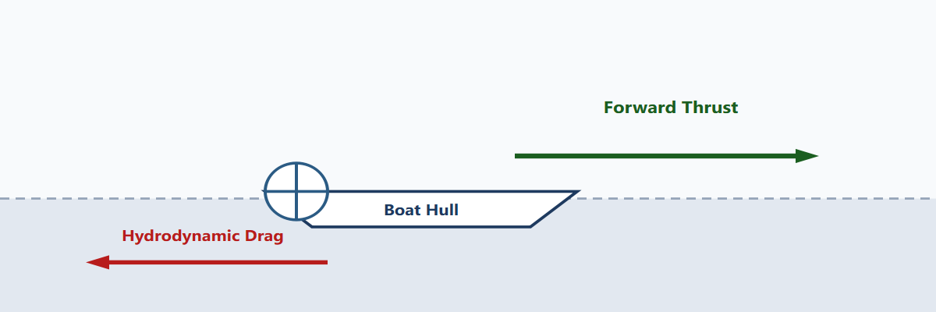
• The rotating paddle blades push backward against the water, and the water exerts an equal forward reaction force on the boat.
• The engine pulls the surrounding air forward into the hull.
• Hydrodynamic drag pushes the boat forward as speed increases.
• The water pulls the boat forward through capillary suction.
• Gravity pulls the boat horizontally across the surface of the water.
• Buoyant forces eliminate the need for any propulsive thrust.
Answer:
____________________________________________
____________________________________________
____________________________________________
5. In fluid mechanics and boat propulsion, in what direction does hydrodynamic drag act relative to the hull's motion?
• Perpendicular upward toward the sky.
• Directly opposite to the direction of the hull's forward motion.
• In the exact same direction as the forward thrust.
• Perpendicular downward toward the seabed.
• At a 45-degree angle pointing northeast at all times.
• Hydrodynamic drag has magnitude only and no physical direction.
Answer:
____________________________________________
____________________________________________
____________________________________________
6. What does the term magnitude strictly denote in physical measurements?
• The compass bearing or spatial direction of a vector.
• The rate at which an object changes its heading.
• The numerical size, amount, or physical quantity expressed by a number and unit, independent of direction.
• The total time elapsed during a physical event.
• The friction coefficient between two touching surfaces.
• The ratio of mass to volume in a substance.
Answer:
____________________________________________
____________________________________________
____________________________________________
7. In the recorded laboratory measurement '18 Newtons upward', which component represents the magnitude?
• Upward
• 18 Newtons (or 18 N)
• Newtons upward
• Zero
• Vertical plane
• The upward acceleration
Answer:
____________________________________________
____________________________________________
____________________________________________
8. Inspect the vector diagrams below:
In scientific illustrations, how is the magnitude of a vector visually indicated?
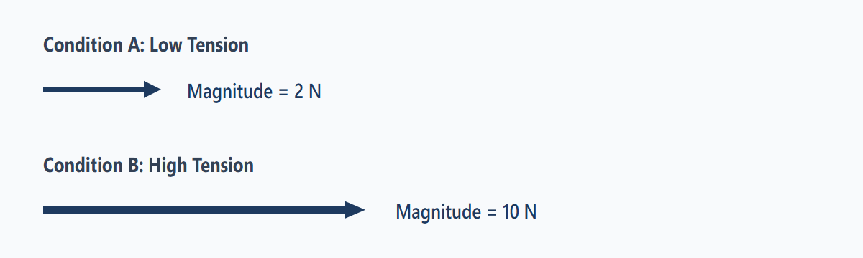
• By the color palette used for the arrow.
• By the physical length of the arrow.
• By the angle the arrow makes with the horizontal axis.
• By the dotted line pattern.
• By whether the arrow points left or right.
• By the font style of the text label.
Answer:
____________________________________________
____________________________________________
____________________________________________
9. Referring to Condition A (2 N) and Condition B (10 N) shown in the vector diagram of Question 8, how many times greater is the magnitude of the force in Condition B compared to Condition A?
• 2 times greater
• 3 times greater
• 5 times greater
• 8 times greater
• 10 times greater
• 20 times greater
Answer:
____________________________________________
____________________________________________
____________________________________________
10. Which statement precisely characterizes a scalar quantity?
• It has magnitude only and is completely described by a number and a unit without direction.
• It must always have both a magnitude and a spatial compass direction.
• It can only describe moving objects in three dimensions.
• It is always represented with an arrow pointing toward the origin.
• It changes value whenever an object rotates in space.
• It is quantified solely in units of Newtons.
Answer:
____________________________________________
____________________________________________
____________________________________________

